# Appendix B:

# Class 1 Wetlands Information

# 

# Walker Ranch – WR11 (SF-LA)

# Walker Ranch – WR6 (SF-LB)

# Walker Ranch – WR9 (SF-XZ)

# Walker Ranch WR-16 (SF-N1)

# Walker Ranch WR-15 (SF-N2)

# Split Oak (SF-WT)

# Tibet Butler (SF-YK)

# Tibet Butler is a Plains wetland that changed stress status from Stressed to Not Stressed. The review of the period-of-record staff gage data indicates that water levels in recent years appear to be on an increasing trend (Figure 4). The field inspection indicated that this wetland is in recovery and not hydrologically stressed (Figure 5).

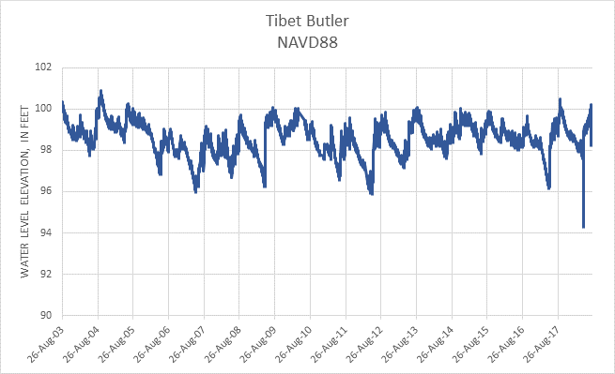

**Figure 4. Period-of-record water level data for Tibet Butler.**

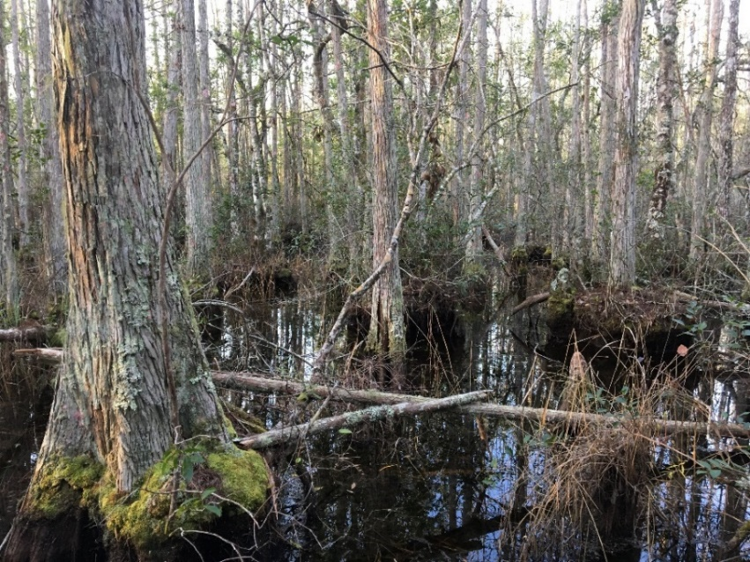

**Figure 5. Tibet Butler, January 30, 2018.**

# Lake Gem (SJ-AJ)

# Lake Gem is a Plains lake that changed stress status from Stressed to Not Stressed (Figure 6). Previous and current evaluations did not reveal ecological indicators of hydrologic stress. The original determination of Stressed appears to be based on the presence of a ditch along the western side of the lake which discharges offsite when the lake reaches higher water levels. However, the hydrology within the lake appears to be stable and consistent with expected regional hydrologic conditions (Figure 7). An analysis of water level data for the period of record selected for the analysis (see Section 4) for Lake Gem indicated that this site is an outlier and not representative of isolated wetlands in the CFWI planning area; therefore, this site was not included in the final, expanded Class 1 wetlands dataset for the analysis in support of the 2020 CFWI RWSP.

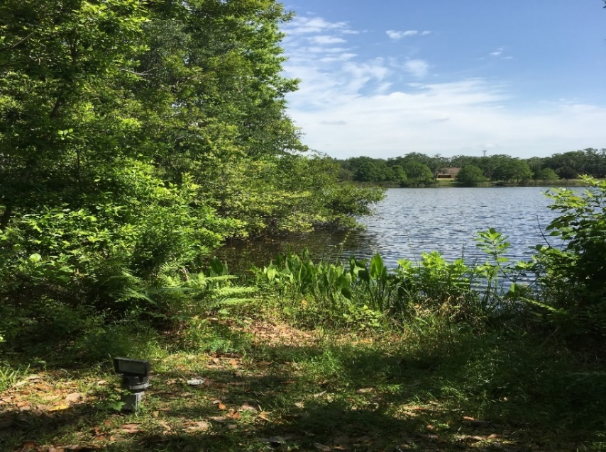

**Figure 6. Lake Gem, May 16, 2018.**

**Figure 7. Period-of-record water level data for Lake Gem.**

# Unnamed Cypress (SJ-LA)

# Unnamed Wetland Near SR 46 (SJ-LB)

# Boggy Marsh (SJ-LC)

# Hopkins Prairie (SJ-LD)

# Lake Avalon (SJ-LE)

# Lake Apshawa (SJ-LF)

# Island Lake (SJ-LH)

# Island Lake is a Plains wetland that changed stress status from Stressed to Not Stressed. Previous and current evaluations did not reveal ecological indicators of hydrologic stress. The original determination of Stressed was based in part on the observation that islands within the marsh system appeared to expand over time based on review of historic aerials dating back to the 1950s. Water levels within the highly urbanized system appear to be stable and consistent with regional climatic conditions, and as indicated by the review of water level monitoring data, surficial aquifer levels have shown an overall increase since 2005 (Figure 8). With the exception of edge effects resulting from the adjacent developments, the marsh system currently appears to be healthy (Figure 9). An analysis of water level data for the period of record selected for the analysis (see Section 4) for Island Lake indicated that this site is an outlier and not representative of isolated wetlands in the CFWI planning area; therefore, this site was not included in the final, expanded Class 1 wetlands dataset for the analysis in support of the 2020 CFWI RWSP.

**Figure 8. Period-of-record water level data for Island Lake.**

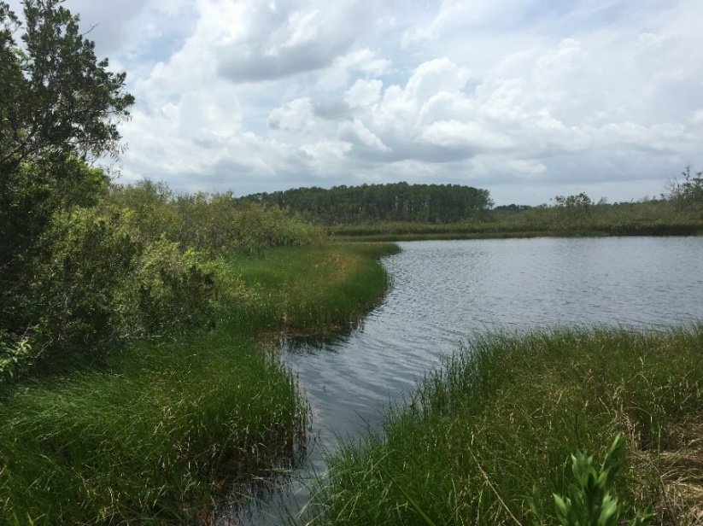

**Figure 9. Island Lake, July 23, 2018.**

# Lake Sylvan (SJ-LI)

Lake Sylvan is a Plains lake that changed stress status from Not Stressed to Stressed. Since the EMT determined the lake to be Not Stressed during the original evaluation, the lake has been visited multiple times. Indicators of hydrologic stress observed during low water periods within the system include the presence of soil fissures within exposed lower reaches of marsh areas, encroachment of pines and invasive species into the wetland areas, exposed tree roots, and the absence of regeneration of wetland tree species along the wetland boundaries (Figure 10). In the past, Lake Sylvan has been subject to flooding during periods of excessive or extended rainfall. To address concerns of flooding from the residential neighborhoods that border the Lake, a gated flood control outfall structure was constructed in 2014. During the evaluation of this system, concerns were raised regarding the outfall structure and its’ potential impact on the determination of stress for the Lake. A review of water level data collected for the lake during the period of record indicated that the water levels within the lake did not appear to reach flood stage or necessitate opening of the structure. Water can still outfall through the structure with the gate closed, but only when water levels reach an elevation close to that of the historic outfall that was present prior to construction of the structure. Water level data indicates that levels within the lake during the selected period of record only exceeded the historic outfall elevation during high water events in 2009 and 2010. Therefore, it is unlikely that the outfall structure, or historic outfall to the ditch, have had a significant impact on water levels within the lake during the selected period of record. A subsequent evaluation of the water level data indicates that the data for the selected period of record reflects a fairly normal distribution of frequency of water level differences from the wetland edge elevation as compared to other Plains wetlands in the dataset.

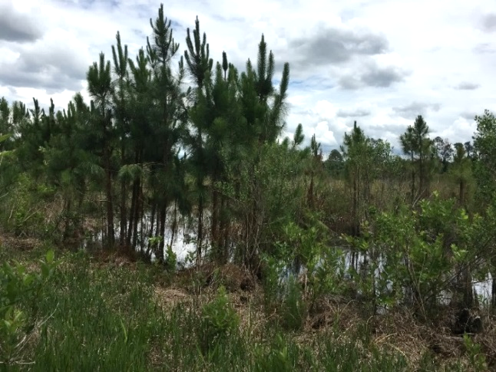

**Figure 10. Lake Sylvan, May 29, 2018.**

**Figure 11. Period-of-record water level data for Lake Sylvan.**

City of Cocoa, Well 9T (SJ-LL)

# Church Lake (SJ-QA)

# Johns Lake (SJ-QB)

# Trout Lake (SJ-QC)

# Long Lake (SJ-QD)

# Lake Louisa (SJ-LJ)

# Prairie Lake (SJ-GA)

Prairie Lake is a stressed Ridge system evaluated for the 2015 EMT analysis and observations of stress made in 2018 were consistent with those made in 2012. Ultimately, the site was not used in the final 2015 analysis due, in part, to problems with consistency in water level data. The period of record selected by EMT staff for calculation of P80 for the 2020 RWSP update is 2009-2017. Although there are still brief periodic gaps, the water level data collected for Prairie Lake during this time frame provides a more consistent set of observations than the data set that included observations from 2006-2008 used in the 2015 analysis. The site was selected as a DMIT monitoring location and transects were established on the northwest and southern sections of the lake. Indicators of stress included encroachment of upland species into wetland areas, observed stressed condition of wetland plant species, and hydrologic indicators observed within the soil at elevations lower than anticipated. A subsequent evaluation of the water level data revealed that the extended low water period experienced in the lake from 2011 through 2017 results in an abnormal distribution of frequency of water level differences from Wetland Edge Reference Elevation as compared to other ridge wetlands in the data set. A determination was made that removal of Prairie Lake from the 2020 analysis may help to normalize the overall Class 1 dataset. EMT staff recommended the removal of Prairie Lake from the 2020 analysis but feel the ongoing monitoring will provide beneficial data and should be considered for future analyses.

**Figure C3. Period-of-record water level data for Prairie Lake.**

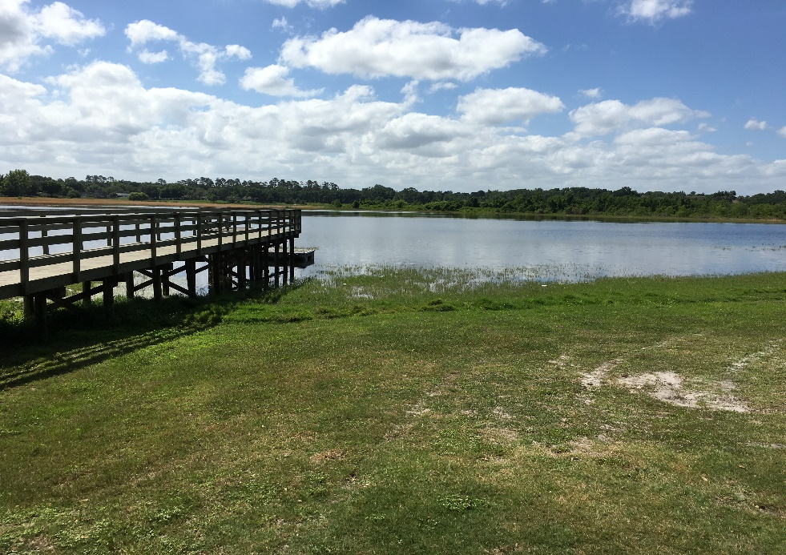

**Figure C4. North Shore of Prairie Lake looking south.**

# Red Bug Lake (SJ-N1)

Red Bug Lake was a Class 2 Stressed Plains wetland used in the 2015 EMT evaluation and observations of stress made in 2018 were consistent with those made in the prior evaluation. Based on review of aerial photographs, there appears to be a historic, significant reduction in the upper lake level, supported by site evaluations conducted by District staff. Zonation of the marsh areas has remained consistent for the last several decades, however, periods of inundation within the marsh areas appear to be reducing in frequency and duration. This may be an ongoing result of the historic reduction in lake level, or a more recent change in hydrologic condition. Drier conditions within the marsh zones have led to the encroachment of woody species.

**Figure C1. Period-of-record water level data for Red Bug Lake.**

# Chapman Marsh (SJ-N2)

Chapman Marsh was a Class 2 Stressed Plains wetland used in the 2015 EMT evaluation and observations of stress made in 2018 were consistent with those made in the prior evaluation. Review of aerials indicate that the wetland was historically an open water system that since the mid 1990’s has become more of a marsh characterized with the invasion of woody species. The system is located within a highly urbanized setting, with a large subdivision bordering the system along the north, east, and southern boundaries, and single-family residences along the western boundary.

**Figure C2. Period-of-record water level data for Chapman Marsh.**

# Green Swamp #7 (SW-AA)

# Lake Garfield (SW-JJ)

# Cypress Creek #199, W17 Sentry Wetland (SW-LE)

# Cypress Creek #190 E Marsh (SW-LF)

# Cypress Creek #190 E Marsh is a Plains wetland that changed stress status from Stressed to Not Stressed. This wetland is located in Tampa Bay Water’s Cypress Creek Wellfield. Groundwater pumping at the wellfield has been reduced in recent years, and as indicated by the review of water level monitoring data, the surficial aquifer levels have increased since 2011 (Figure 12). The field inspection indicated that this wetland is not hydrologically stressed, and while many trees have been lost, it is recovering (Figure 13). However, an analysis of water level data for the period of record selected for the analysis (see Section 4) for this marsh indicated that it is an outlier and not representative of isolated wetlands in the CFWI planning area; therefore, this site was not included in the final, expanded Class 1 wetlands dataset for the analysis in support of the 2020 CFWI RWSP.

**Figure 12. Period-of-record water level data for Cypress Creek #190 E Marsh.**

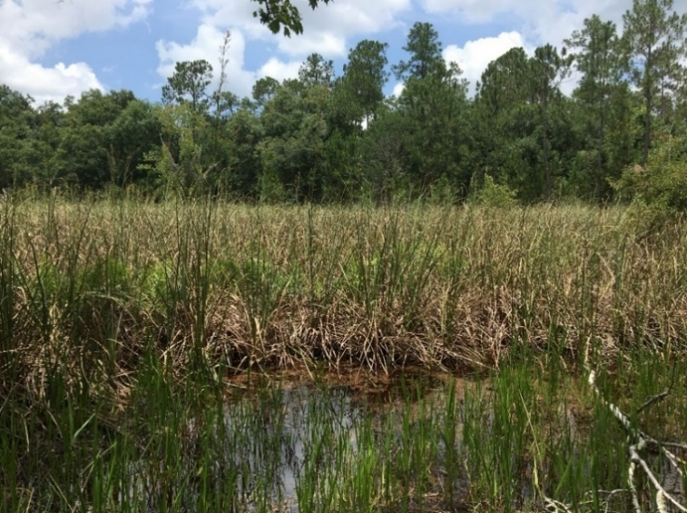

**Figure 13. Cypress Creek #190 E Marsh, June 1, 2018.**

# Cypress Creek #223 B W46 (SW-LG)

# Cypress Creek #211 W33 (SW-LH)

This wetland is a Plains wetland that changed stress status from Stressed to Not Stressed. Cypress Creek #211 W33 is located in Tampa Bay Water’s Cypress Creek Wellfield. Groundwater pumping at the wellfield has been reduced in recent years, and as indicated by the review of water level monitoring data, with the exception of the early 2017 drought, the surficial aquifer levels have increased in recent years (Figure 14). The field inspection indicated that this wetland is not hydrologically stressed (Figure 15).

**Figure 14. Period-of-record water level data for Cypress Creek #211 W33.**

# 

**Figure 15. Cypress Creek #211 W33, June 1, 2018.**

# Green Swamp Marsh #304 (SW-LI)

# Green Swamp #6, #303 (SW-LJ)

# Green Swamp #5, #302 (SW-LK)

# Green Swamp #1, #298 (SW-LM)

# Lake Wales (SW-MM)

# Lake Wales (also known as Lake Wailes) is a Ridge lake that changed stress status from Stressed to Not Stressed. The review of the period-of-record staff gage data indicates that lake levels have been stable since 2002, with levels after 2002 typically higher than before 2002 (Figure 16). In addition to the stable water levels for many years, a review of historical aerials and the field inspection indicated that the lake is not hydrologically stressed (Figure 17). Lake Wales is meeting its Minimum Level, but is currently not meeting its High Minimum Level.

**Figure 16. Period-of-record water level data for Lake Wales.**

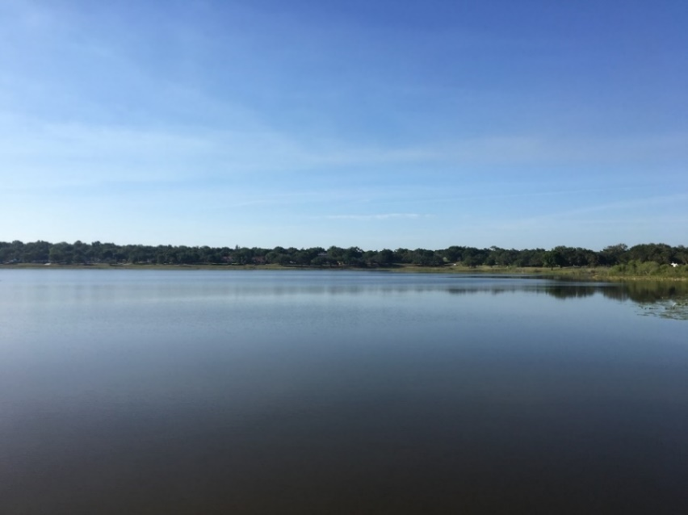

**Figure 17. Lake Wales, April 19, 2018.**

# Big Gum Lake (SW-QA)

# Big Gum Lake is a Ridge lake that changed stress status from Stressed to Not Stressed. The staff gage data for this lake indicates stable water levels since about 2010 (Figure 18). As shown on historical aerial photographs, a large ditch was constructed in the northern portion of the lake some time during the 1940s; however, since the 1970s, lake levels have been relatively stable. Combined with the period-of-record water level data and the review of historical aerials, the field inspection indicated that the lake is not hydrologically stressed (Figure 19).

**Figure 18. Period-of-record water level data for Big Gum Lake.**

# 

**Figure 19. Big Gum Lake, April 19, 2018.**

# Bonnet Lake (SW-QB)

# Buck Lake (SW-QC)

# Gator Lake (SW-QD)

# Gator Lake is a Ridge lake that changed stress status from Not Stressed to Stressed.

# While the review of the historical aerials from the 1940s through the present indicates no change in the lake level, the field visit indicated hydrologic stress in the wetlands along the lake shore on the site where the staff gage is accessed (Figures 20 and 21). A review of the staff gage data from the mid-1990s through the present indicates more fluctuation in lake levels prior to 2010 as compared to after 2010; the lowest lake levels were recorded before 2010, and levels since 2010 have been more stable (Figure 22).

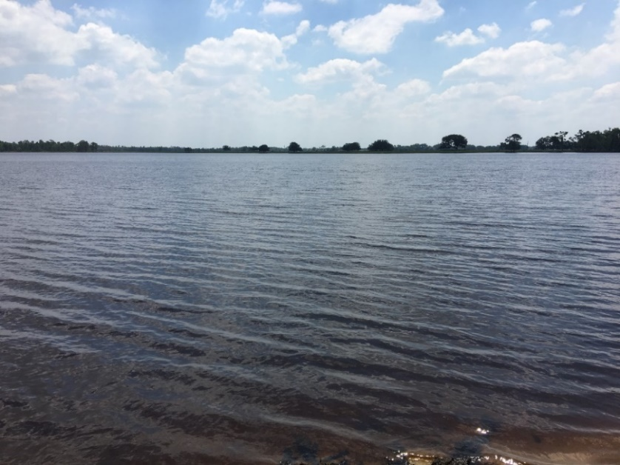

**Figure 20. Gator Lake, April 19, 2018.**

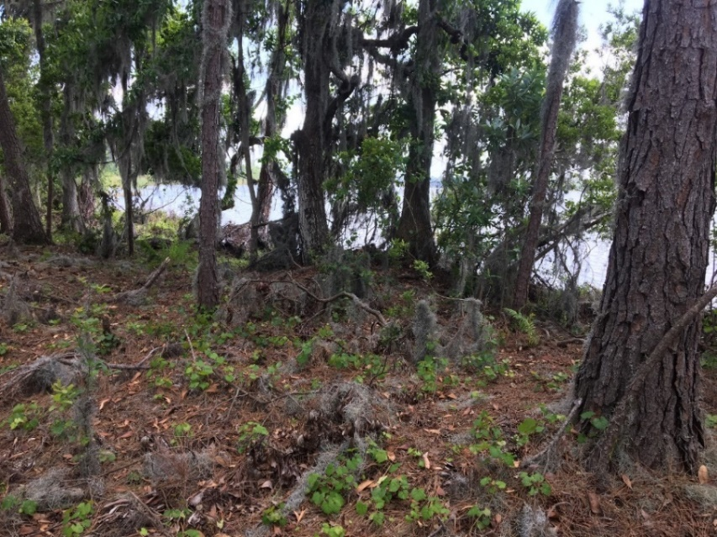

**Figure 21. Shoreline Wetlands Along Gator Lake, April 19, 2018.**

**Figure 22. Period-of-record water level data for Gator Lake.**

# Lake Annie (SW-QE)

# Lake Apthorpe (SW-QF)

# Lake Leonore (SW-QH)

# Lake Placid (SW-QI)

# Lake Streety (SW-QJ)

# Lake Van (SW-QK)

# Lake Walker (SW-QL)

# Polecat Lake (SW-QM)

# Polecat Lake is a Ridge lake that changed stress status from Stressed to Not Stressed. The review of the historical aerials indicated stable lake levels. Since about 1991, lake water levels have been stable, with lowest levels recorded during the mid-1980s (Figure 23). The field inspection indicated that the lake was of poor quality because of water quality issues but not hydrologically stressed (Figure 24).

**Figure 23. Period-of-record water level data for Polecat Lake.**

# 

**Figure 24. Polecat Lake, April 19, 2018.**

# Surveyors Lake (SW-QN)

# Parks Lake (SW-QO)

# Crooked Lake (SW-QQ)

# Crooked Lake is a Ridge lake that changed stress status from Stressed to Not Stressed. The review of the historical aerials indicated a stable lake over time with levels varying from low to high depending on rainfall conditions. The period-of-record staff gage data indicates that lake levels have increased in recent years (Figure 25). There is historical evidence that water was pumped directly from the lake for irrigation; removal of this stressor may have contributed to the recent increased lake levels. In addition, historical lake levels were most likely affected by agricultural pumping from the aquifer, and this pumping was greatly reduced after freezes during the 1980s. The lake was not hydrologically stressed during the field inspection (Figure 26). The 2017 assessment indicated that Crooked Lake is meeting its minimum levels.

**Figure 25. Period-of-record water level data for Crooked Lake.**

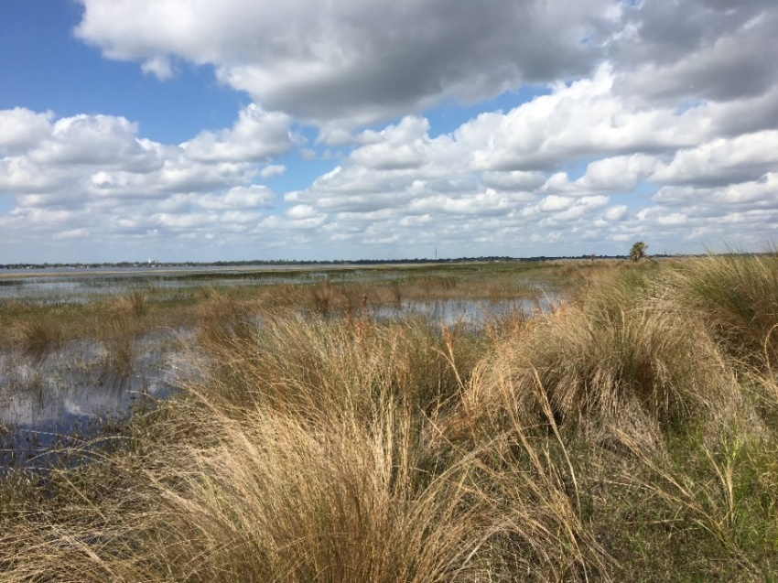

**Figure 26. Crooked Lake, February 27, 2018.**

# Green Swamp Bay (SW-N1)

# Green Swamp #4 (SW-N2)

# Alston Bay (SW-N3)

# NE Lakeland Wellfield G (SW-N4)

# NE Lakeland Wellfield J (SW-N5)

# NE Lakeland Wellfield K (SW-N6)

# Lake Wales Ridge Wildlife and Environmental Area, Mountain Lake Cutoff Tract #2 (SW-N9)

# Saddle Blanket Scrub #2 (SW-N8)

# Van Fleet #2 (SW-N7)